**Neural Networks & Deep Learning**

**Assignment:8**

**Name:Bhuvana Nandhimalla**

**ID-700744203**

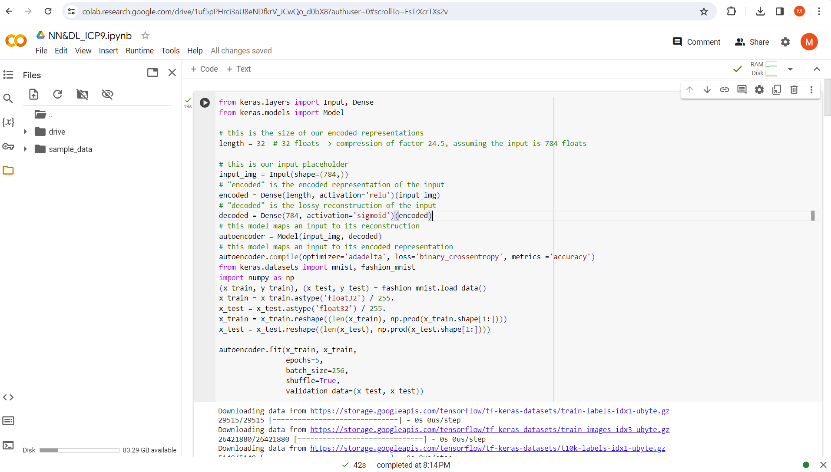

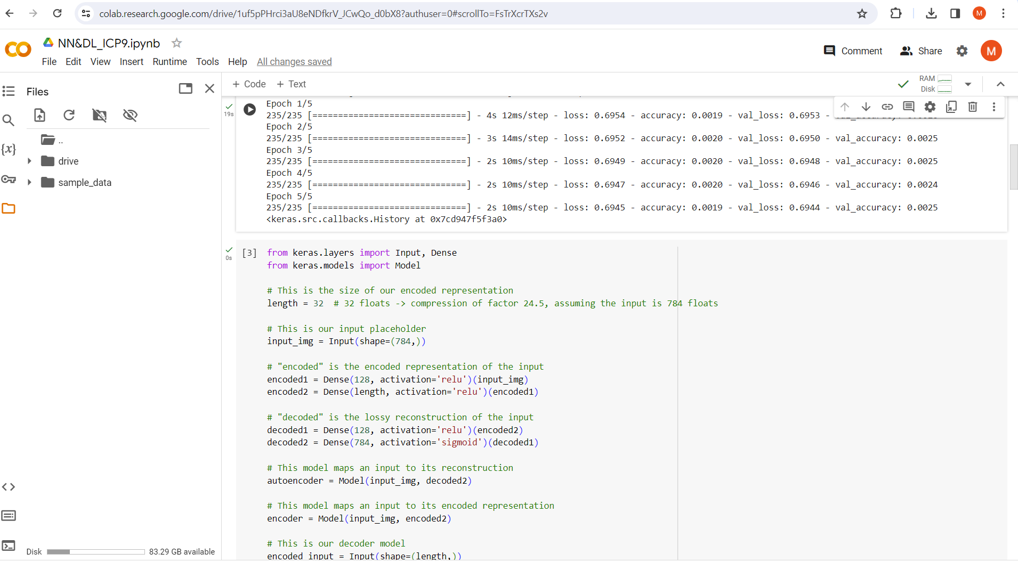

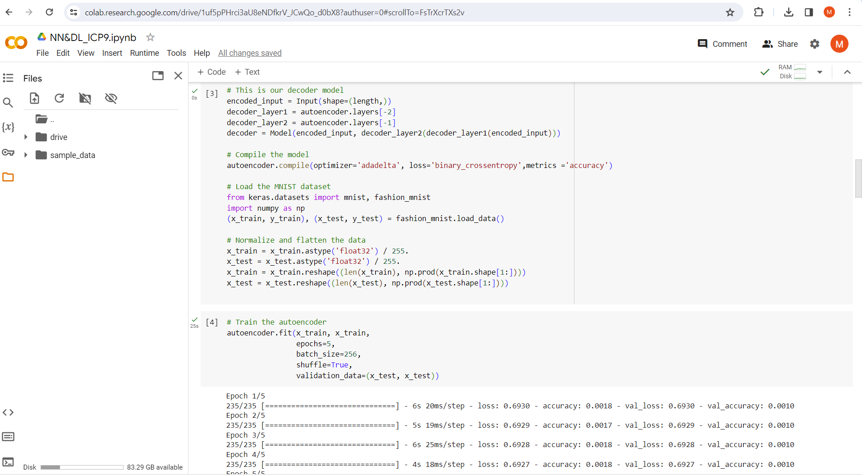

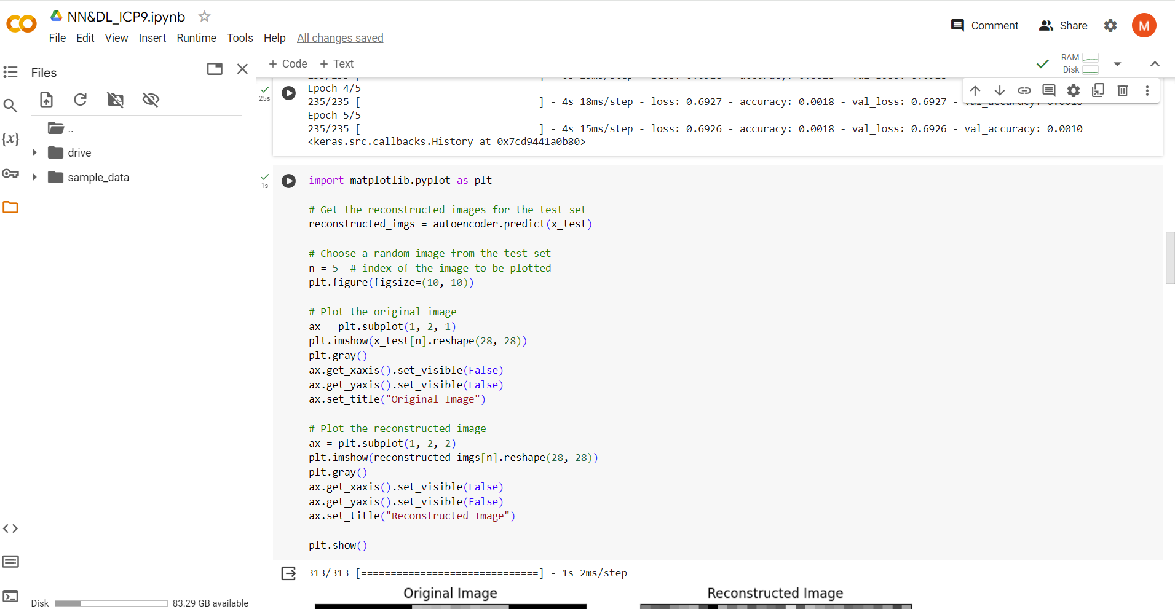

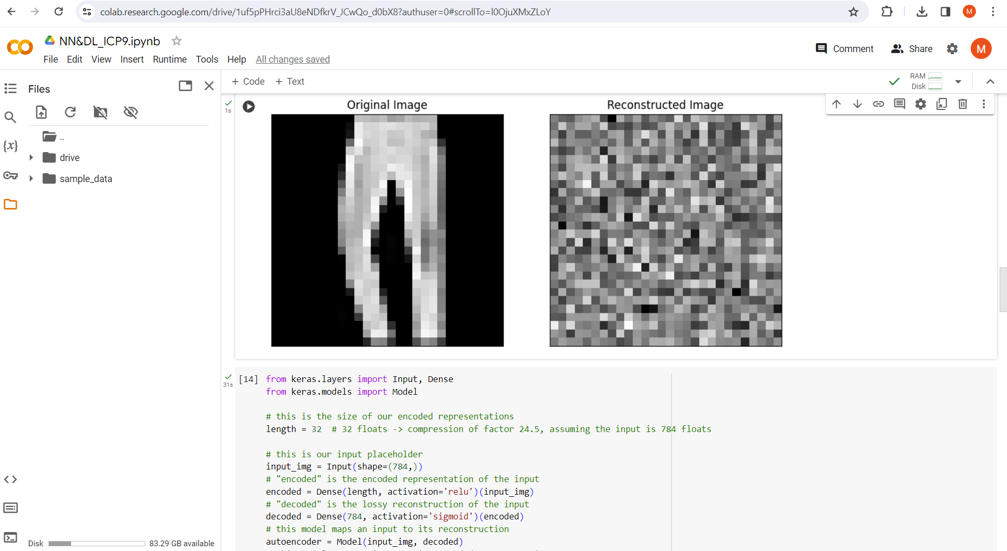

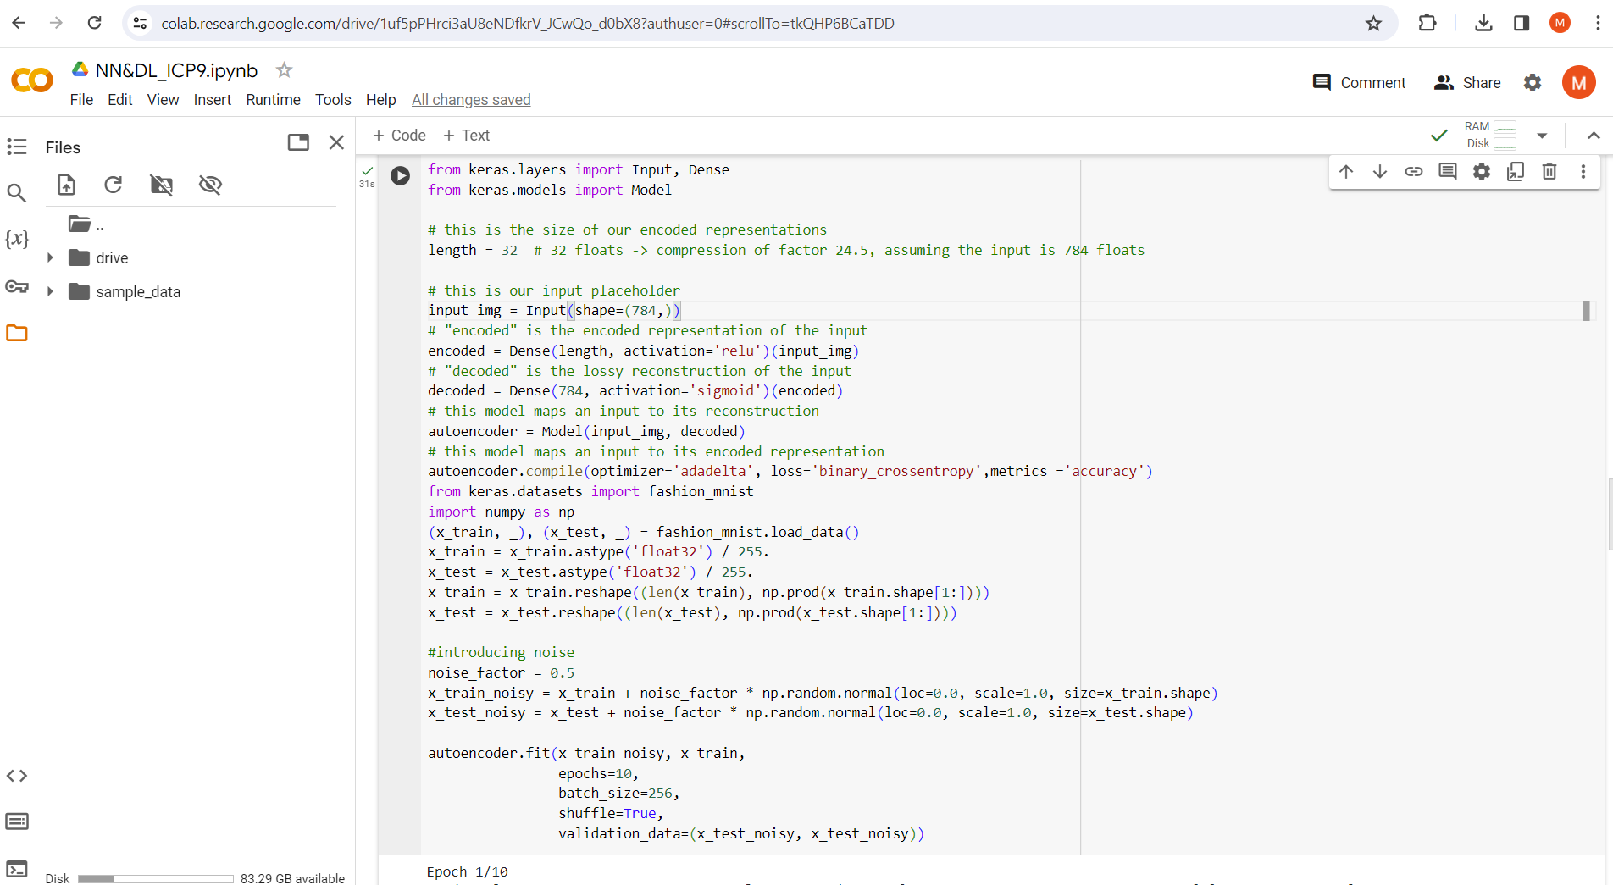

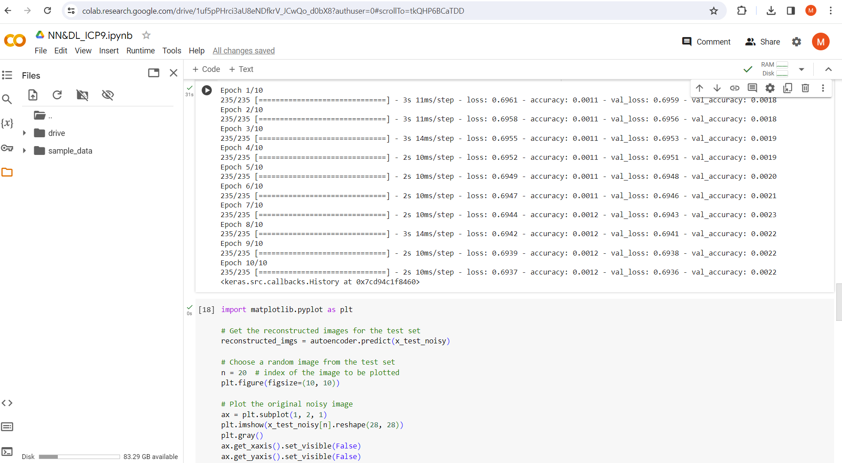



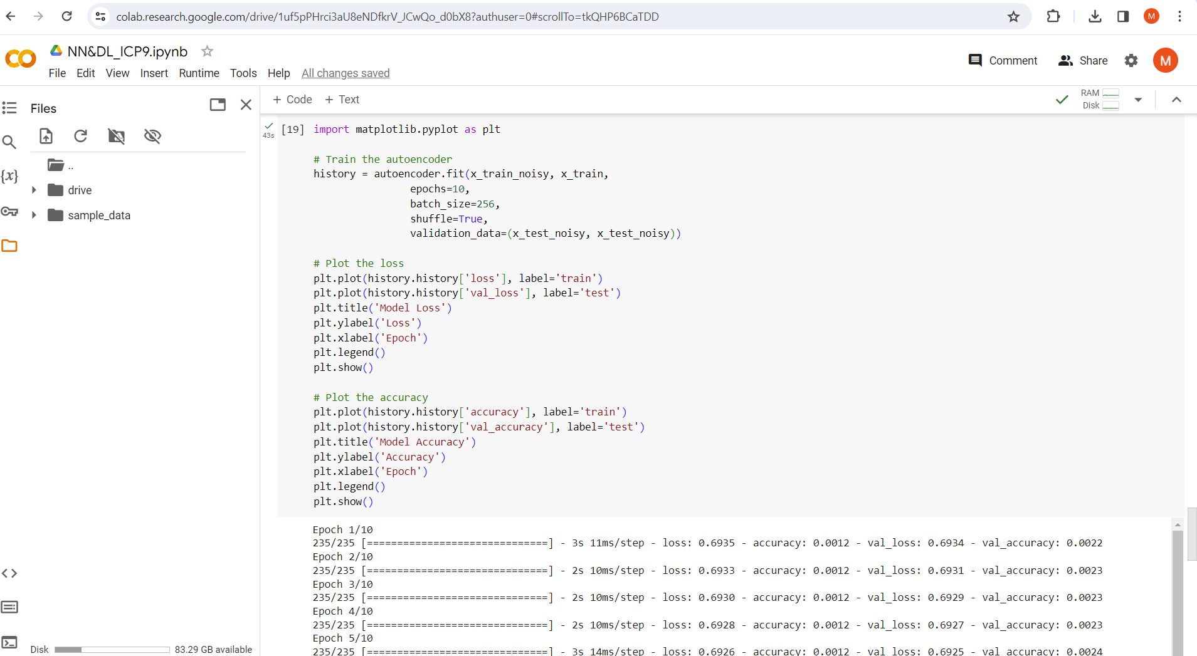

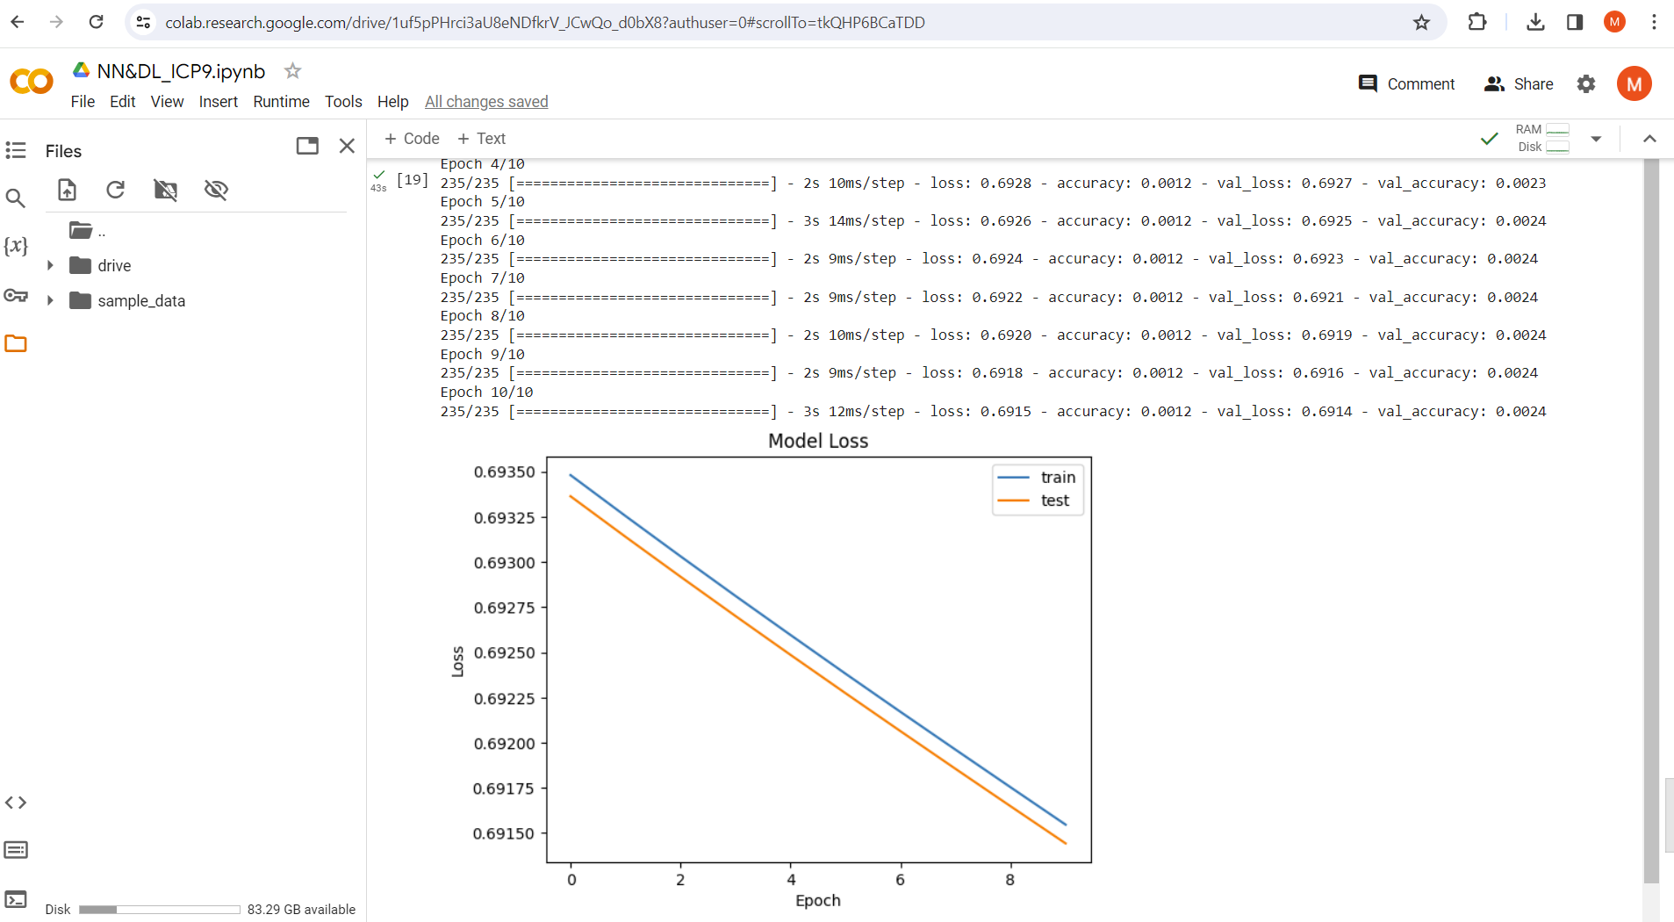

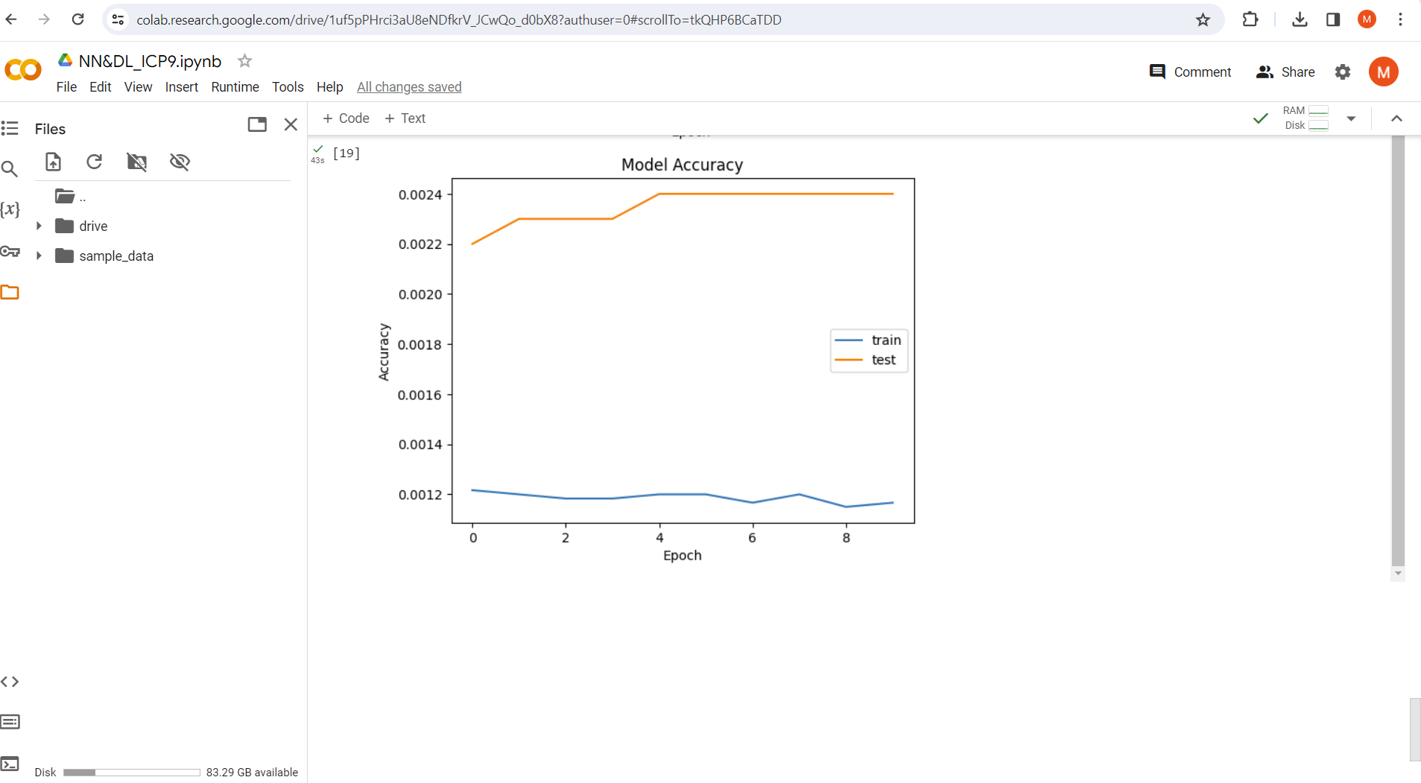

Github Link---https://github.com/BhuvanaNandhimalla/NeuralNetworks_Assignment8

Video Link--https://drive.google.com/file/d/1En4PSdM7bF89ea1_FGkcALUAQg-RqWCM/view?usp=sharing